**YOUR DATA, YOUR RIGHT**

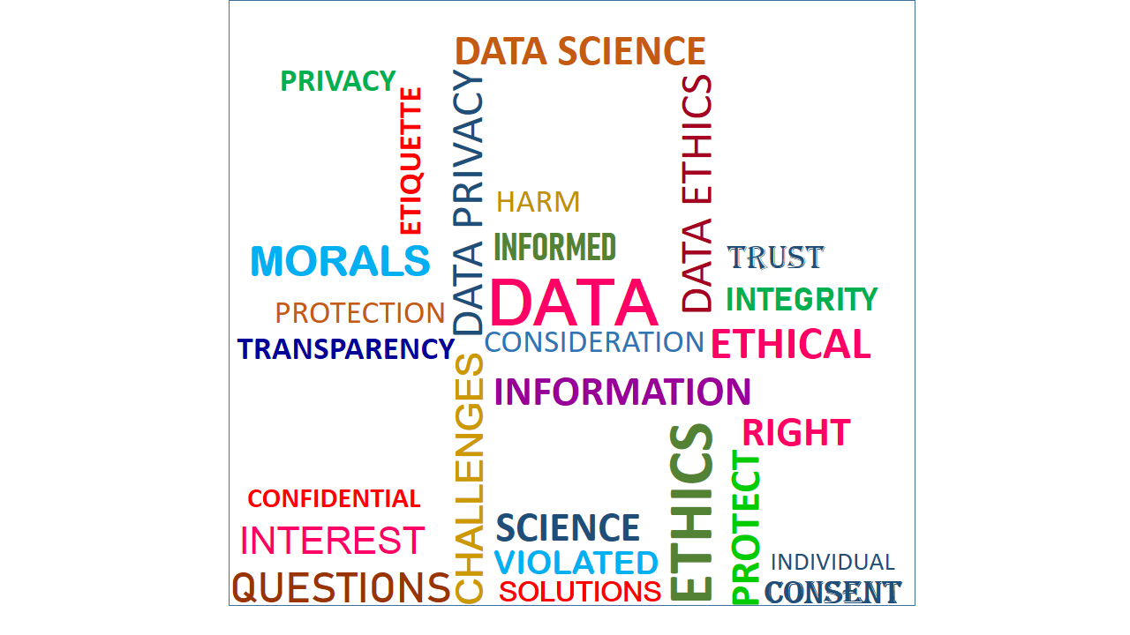

**Introduction**

Data Science and data ethics are two interconnected fields that have gained significant attention in recent years. Data science involves the extraction, analysis, and interpretation of large sets of data to gain insights and make informed decisions. On the other hand, data ethics focuses on the moral and ethical considerations surrounding the collection, use, and sharing of data. In the context of data science and data ethics, it is important to consider issues such as privacy, consent, bias, transparency, and accountability. For example, data scientist must ensure that they use data in a way that respects individual's privacy and also ensure they obtain proper consent for data collection. They must also be aware of potential biases in the data and take steps to mitigate them to avoid unfair or discriminatory outcomes. Ethical considerations in data science also extend to the responsible use of data-driven insights. It is crucial to ensure that the conclusions drawn from data analysis are accurate, reliable and unbiased. Additionally, transparency and accountability are essential in communicating the findings and implications of data science projects to stakeholders and the wider public. By addressing these ethical considerations, data scientist can contribute to the development of responsible and trustworthy data practices. This will help protect individual rights and interests, foster public trusts in data science and its potential benefits.

This article focuses on two ethical challenges: Data privacy and informed consent, real world examples, data ethics questions related to the challenges, potential harms and potential solutions that can help mitigate or eliminate the adverse effect of this challenges.

**Data Privacy**

Data privacy, sometimes also referred to as information privacy, is an area of data protection that concerns the proper handling of sensitive data including, notably, personal data but also other confidential data, such as certain financial data and intellectual property data, to meet regulatory requirements as well as protecting the confidentiality and immutability of the data.

**Real World Example**: A scenario where a healthcare organization, aiming to enhance patient care, decides to share patient data with a third-party analytics company without obtaining explicit consent from the individuals. This data includes sensitive information such as medical history, treatment plans, and genetic data. The analytics company, in turn, uses this data to develop predictive models for disease outcomes. This situation raises serious data privacy concerns as patients' personal information is shared without their informed consent.

**Data Ethics Questions**

1. Were patients properly informed about the data sharing, and did they provide explicit consent for such usage?
2. Is the healthcare organization sharing only the necessary data for the intended purpose, or is it sharing more information than required?
3. How is the third-party analytics company safeguarding the shared data, and what measures are in place to prevent unauthorized access or breaches?

**Potential Harms**

1. Patients may feel violated as their sensitive health information is shared without their knowledge, potentially leading to a loss of trust in the healthcare system.
2. Inadequate security measures could expose patients to the risk of identity theft or other malicious activities.
3. Predictive models based on shared data might lead to stigmatization or discrimination against certain individuals based on their health conditions.

**Potential Solutions**

1. Ensure that patients provide explicit and informed consent before their data is shared, clearly outlining the purposes and entities involved.
2. Implement robust data anonymization techniques to minimize the risk of re-identification while still allowing for valuable insights.
3. Establish an independent ethical review board to evaluate and monitor data sharing agreements to ensure compliance with privacy norms.

**Informed consent**

Informed consent is one of the founding principles of research ethics. Its intent is that human participants can enter research freely (voluntarily) with full information about what it means for them to take part, and that they give consent before they enter the research. Consent should be obtained before the participant enters the research (prospectively), and there must be no undue influence on participants to consent. The minimum requirements for consent to be informed are that the participant understands what the research is and what they are consenting to.

**Real World Example**: A scenario where a genetic research institute, in its pursuit of scientific advancements, collects DNA samples from participants without obtaining truly informed and explicit consent. The participants are not fully aware of the potential uses of their genetic data, including research beyond the initially stated scope. This lack of comprehensive informed consent raises significant ethical concerns in the realm of genetic research.

**Data Ethics Questions**

1. Were participants provided with clear and detailed information about the potential uses of their genetic data, ensuring they fully understood the scope and implications?
2. Is the consent process dynamic, allowing participants to update their preferences and approvals as the research evolves, or is it a one-time, static agreement?
3. Do participants have a clear understanding of who owns their genetic data, and are they given the option to retract consent and have their data removed from the research?

**Potential Harms**

1. Participants may feel a loss of control over their genetic information, leading to concerns about potential misuse or unintended consequences.
2. Inadequate informed consent practices can erode trust between research institutions and participants, hindering future collaboration and recruitment efforts.
3. Without proper informed consent, researchers may unknowingly engage in practices that lead to stigmatization, discrimination, or other negative outcomes.

**Potential Solutions**

1. Ensure that the informed consent process is thorough, providing participants with a comprehensive understanding of how their genetic data will be used.
2. Establish channels for ongoing communication with participants, updating them on the progress of the research and any changes in data usage policies.
3. Involve an independent ethics review board to assess and oversee the informed consent process, ensuring it aligns with ethical standards and guidelines.

**Conclusion**

In the intersection of data science and ethics, privacy and informed consent emerge as stalwarts, guarding individual rights. The examples of healthcare data sharing and genetic research underscore the need for ethical considerations. The challenges outlined demand our commitment to principled practices. To navigate this landscape responsibly, let's champion explicit and informed consent, employ robust anonymization, and establish independent ethical review boards. In doing so, we not only safeguard trust but also contribute to a future where data-driven insights coexist harmoniously with ethical principles.

Embrace ethical data practices, for in that embrace, we shape a future where progress and responsibility walk hand in hand.

1. Top of Form

**Related Resources**

1. "The Price of Free: Privacy Violations in Social Media" - Article discussing the privacy implications of free social media platforms: The Price of Free

2. "Privacy on Social Media" - Research paper exploring the challenges of maintaining privacy on social media platforms: Privacy on Social Media

3. "California Consumer Privacy Act (CCPA)" - Overview of the CCPA, a privacy law that enhances consumer protection rights: CCPA Overview

4. "Genetic Privacy: An Evolving Landscape" - Article discussing the challenges and considerations in genetic data privacy: Genetic Privacy

5. "Dynamic Consent: A Patient Interface for Twenty-First Century Research Networks" - Research paper exploring the concept of dynamic consent in research: Dynamic Consent

6. "The Importance of Informed Consent in Genetic Research" - Blog post highlighting the ethical importance of informed consent in genetic studies: Informed Consent in Genetic Research